Birding along the Silk Road - Uzbekistan

There is no better destination in Central Asia for a mix of a Birding & Culture tour than in Uzbekistan. If you visit any of the ancient cities of Tashkent, Samarkand or Bukhara it will be obvious how rich these cities were during the Middle Ages and how much they still retained of the original splendor of architecture and traditions. As we follow the steps of the Silk Road we will be amazed how variable the scenery can be from high mountains through river valleys and lakes down to semi-deserts and the Kyzyl Kum desert itself.
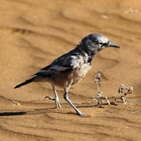
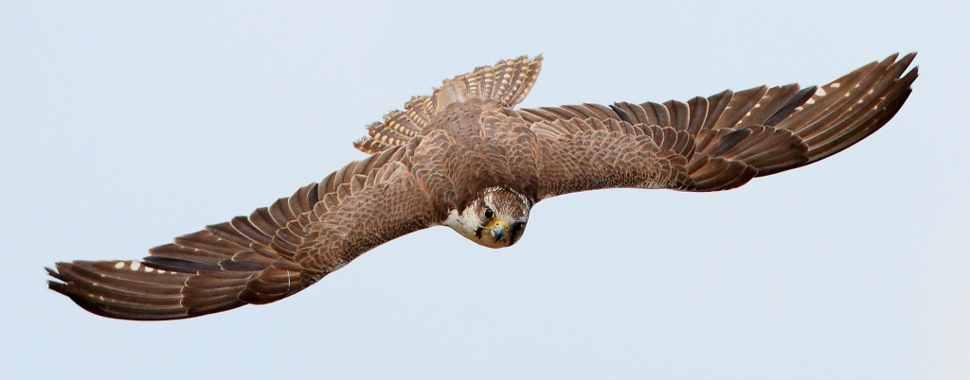
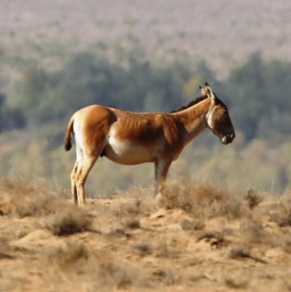
Obviously all these different habitats offer a wide variety of birds & other wildlife. In the hilly region we will look for raptors which include Himalayan Griffon Vulture, Griffon Vulture, Bearded Vulture, Long-legged Buzzard, Shikra, Saker Falcon and many more, while the most special bird to look for will be Pander’s Ground Jay in the desert where we also have a chance for Asian Desert Warbler, Desert Finch, Southern/Steppe Grey shrike, Desert White-throat, & Streaked Scrub Warbler.

In between the hills and the deserts we visit diverse habitats where we should add such various species as Turkestan Tit, Grey-necked - & White-capped Bunting, Eastern Rock Nuthatch, Turkestan Shrike, White-winged Woodpecker, Asian Paradise Flycatcher, Finsch’s Wheatear, White-throated Robin, Sykes Warbler, Menetries’s warbler, Rosy Starling and many more.
What is more, beside the excellent species of birds there is a good chance to see some other interesting wildlife, like Goitered Gazelle, Wild Asian Ass, Przewalski’s Horse and various reptiles, unique wildflowers and rare butterflies.
Day 1 Start from London to Taskent, arrival on 2nd day early morning.
Day 2
After arriving to Tashkent in the morning we drive up to Chimgan Mountain, which is part of Chatkal Mountain Range in the Western Tien Shan. On the way we will stop alongside a river. Our first birds will include Common Myna, Barn & Red-rumped Swallow, Masked Wagtail and we check some nearby bushes for White-crowned Penduline Tits and other songbirds such as Tree Sparrow as well. Black-winged Stilt, Green -, Common and Marsh Sandpiper, Great Cormorant all possible alongside the water, while in the air we should find Little & Common Tern, Black Kite & perhaps Short-toed Eagle. Rose-coloured Starling and Eurasian Roller can add further colours to the list.
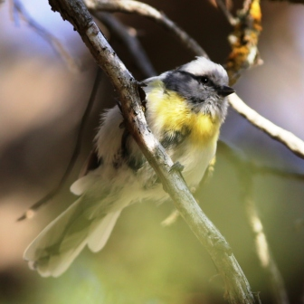
Later on we turn on roads which climb higher where we will have a good chance to see more raptors, for example Long-legged Buzzard or Booted Eagle. We might see our first European Bee-eaters and Lesser Grey Shrikes.
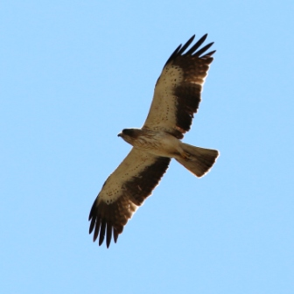
Although we will not drive up extremely high in the hills, still we will feel considerably cooler than in the usually hot city of Tashkent. After checking in we have a lunch with fantastic view on the surrounding hills.
During the afternoon first we will check the sky for Raptors for Shikra, Hobby, pale and dark forms of Booted Eagle and Long-legged Buzzard.
Later we have a walk to look for Turkestan Tit, Yellow-breasted Tit & Rufous-naped Tit. We surely will have loads of Chiffchaffs and European Bee-eaters as well, while Rock Bunting is not uncommon either.
Stay at Chimgan Hills
Day 3
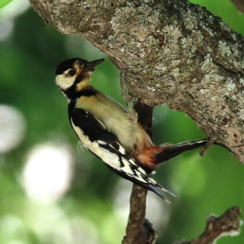
During a pre-breakfast morning birding at Chimgan we will try to find tits again, especially if we had missed any of the local species yesterday. Other common birds are Spotted Flycatcher, House Martin, Barn Swallow, Whitethroat, Lesser Whitethroat, Blackbird, Nightingale, Rock Sparrow and Common Rosefinch. But there is a good chance to find Asian Paradise Flycatcher, White-capped Bunting, Golden Oriole and Indian Oriole as well. Other local specialty is White-winged woodpecker which we should find even in the garden of our hotel.
After breakfast we stay in the terrace for a while to look above the valley among the hills where more and more raptors will appear in the warming up air. Beside Black & European Griffon Vulture we hope to find Himalayan Griffon Vulture as well. Apart from some more Booted Eagles we hope to see Golden Eagle as well.
After checking out we leave the hills and on the way down to Tashkent we can stop alongside the river again for a short birding and we spend the rest of the day with sightseeing in Tashkent.
Stay in Tashkent
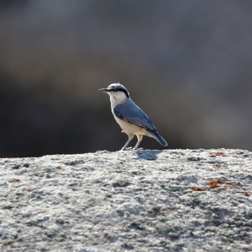
Day 4
After breakfast today we travel from Tashkent to Samarkand. During the first part of the travel we cross a relatively flat area where we will see regularly Eurasian Rollers and Bee-eaters, Barn Swallows, Jackdows, Rooks and Lapwings. We will break the journey to photograph the strange mega-nesting development of White Storks on huge pylons.
After a few hours we arrive to Dzhizak Pass & Tamerlan Gate with huge cliffs. This is an excellent place for European Griffon Vulture & Egyptian Vulture. Lesser Kestrel and Saker Falcon might be in the air as well. This is also a place where we will try to find Variable Wheatear & Eastern Rock Nuthatch.
Later on we arrive to Samarkand where we have lunch and in the late afternoon try to discover the incredibly rich architecture of the town. There are so many things to see that it will not be an easy decision which one we should leave out: Gur Emir, Uluk Beg’s Observatory, Grave of Prophet Daniel, Shak-i Zinda Necropolis, Bibi Khani or Registan.
Night at Samarkand
Day 5
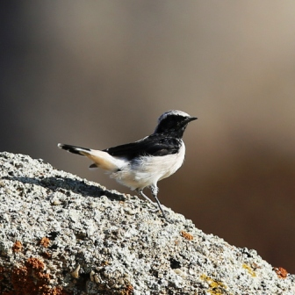
After an early breakfast we aim to leave as early as possible up to the Takta-Karacha Pass. But before we reach that area we will stop at a place where the huge rock boulders give a perfect habitat for Finsch’s Wheatear and Crested Lark.
Later on we stop at a slightly wooded area where we have a good chance to find Upcher’s warbler, Eastern Orphean Warbler and Grey-headed Goldfinch. This site offers a second chance to find White-winged woodpecker, Yellow-breasted Tit & Turkestan Tit.
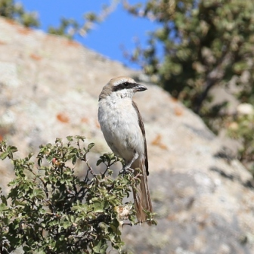
We continue our way to the Takta-Karacha Pass which is about at an elevation of 1600m. We will be flexible with timing of our picnic lunch, depending on how desperate you will be to look for such new species as Turkestan Shrike and White-throated Robin. But we will take our time and we can find some pleasant shady trees with a little stream along, both act as real magnets for the birds. We will check carefully all the warblers on the few trees around and identify Eastern Olivaceous Warbler, Eastern Orphean Warbler and Hume’s Leaf Warbler. Among the ground-feeders we hope to find Hume’s Short-toed Lark & White-capped Bunting and between the rocky areas Pied Wheatear, Chukar, Rock Bunting and Eastern Rock Nuthatch.

On the way back we might stop again to double check the birds at the same place to add anything we have missed on the way up.
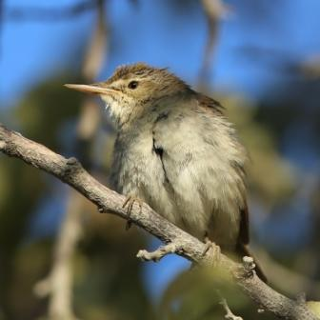
Arriving back to Samarkand you have a chance to see some more historical sights, shop some unique local things in the bazaar or just rest a bit.

Day 6
We keep the routine of having an early, but substantial breakfast and start from our hotel and this morning within half an hour we will be at Zeravshan River. Here alongside the sandy bank loads of dirt trails meander with dense scrubby-bushy vegetation along, full with birds. Although most of them Sparrows, we should find Rufous-tailed Scrub Robin, Long-tailed Shrike, Savi’s Warbler and several other species among them. Loads of Eurasian Bee-eaters should be in the air, plus a few Common Terns, Turtle Doves and from time to time an Eastern Marsh Harrier makes all te birds move.
After an hour or so we move forward as well and within an hour we should arrive to an extensive fishpond system. This is a paradise for wetland and reed-bed birds, such as Clamorous/Turkistan Reed Warbler, Reed Bunting, Paddyfield Warbler, Blyth’s Reed Warbler, Sykes Warbler, Thick-billed Warbler, White-crowned Penduline Tit and Moustached Warbler. We should see Common Black-backed & Masked Wagtail, plus will try to find among the vegetation Rufous-tailed Scrub Robin, Pied Bushchat & Rustic Bunting.
During picnic we keep an eye on the birds flying over, including Eurasian Rollers and Blue-cheeked Bee-eaters which always add nice colours to the seen birds.
On the water and at the edges several species will search for food such as Little Grebe, Common Coot, Moorhen, Pygmy & Great Cormorant, Common Snipe, Purple-, Grey- & Night Heron, Water Rail, Green & Wood Sandpiper, Little Egret, Black-winged Stilt, Ferruginous Duck.
Later in the afternoon we travel further on the Golden Road to Bukhara, where after checking in our hotel we can discover the splendid mediaeval town with a sightseeing walk.
Night in Bukhara.
Day 7
As usual, another early departure before the Sun starts to bake. This time we head out to North of the city deeper into the famous Kyzyl Kum desert. Our main target here will be the unique Pander's Ground Jay. It is quite interesting to see this highly adapted species to run among the sand dunes, searching for food. With some luck we might have one to perch on a bush as well.
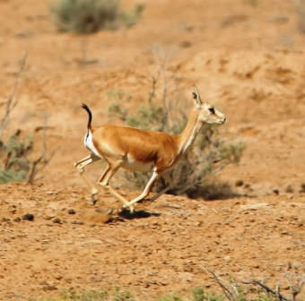
It will be fascinating to check all the signs in the sand left by different creatures including meandering snakes, lizards and with luck even Persian Sand Cat footprints what we found during our 2014 tour.
Isabelline Wheatear, Blue Whistling Thrush & Streaked Scrub Warbler also possible, while any small stops before or after the desert with some trees can produce Desert Lesser Whitethroat, Whitethroat, Blyth’s Warbler and some other songbirds.
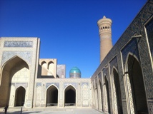
We have a late lunch in Bukhara and then we drive out again, this time South of the town. Less than within an hour we will be at a protected area which is famous for having a good population of Goitered Gazelle, Przewalski’s Horse & Wild Asian Ass or Kulan. Beside having good views of all 3 special mammals, in 2014 we added a few bird species as well, such as Black-bellied Sandgrouse and any small ponds or water-bodies can be magnets for plovers, ducks and other birds as well such as Black-winged Stilts, Blue-cheeked Bee-eaters, Caspian Gulls, but we had seen even Terek Sandpiper before. This is also an area for Black-headed Wagtail, Southern or Steppe Grey shrike, Menetries’s warbler and Rosy Starling.
Finally we arrive back to Bukhara in the evening.
Day 8
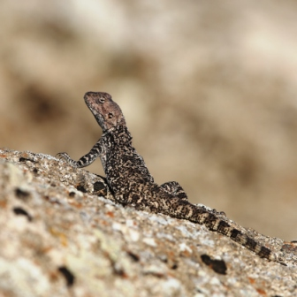
Today we take it easy in the morning, so you will have time either to relax or catch up with any missed cultural sight in Bukhara before we drive to the nearby airport to have a short midday flight to Tashkent.
From Tashkent you will have a connection either to London or if you choose the Kazahstan extension than to Almaty.
Day 9
Arrival to London or Kazahstan

